Experiment 11

Aim: Create two tables `Books` (book_id, title, author, price) and `Sales` (sale_id, book_id, sale_date, quantity). Retrieve the details of books sold along with their sales information.

Procedure:
1. Create the tables:

CREATE TABLE Books (
book_id INT PRIMARY KEY,
title VARCHAR(255),
author VARCHAR(255),
price DECIMAL(10, 2)
);

CREATE TABLE Sales (
sale_id INT PRIMARY KEY,
book_id INT,
sale_date DATE,
quantity INT,
FOREIGN KEY (book_id) REFERENCES Books(book_id)
);

2. Insert values:

INSERT INTO Books (book_id, title, author, price) VALUES
(1, 'Database Systems', 'Elmasri', 45.50),
(2, 'Data Mining', 'Han', 55.00),
(3, 'Operating Systems', 'Silberschatz', 65.00);

INSERT INTO Sales (sale_id, book_id, sale_date, quantity) VALUES
(1, 1, '2024-11-01', 10),
(2, 2, '2024-11-03', 5),
(3, 1, '2024-11-05', 3);

3. Query to retrieve book details with sales information:

SELECT Books.title, Books.author, Sales.sale_date, Sales.quantity
FROM Books
JOIN Sales ON Books.book_id = Sales.book_id;
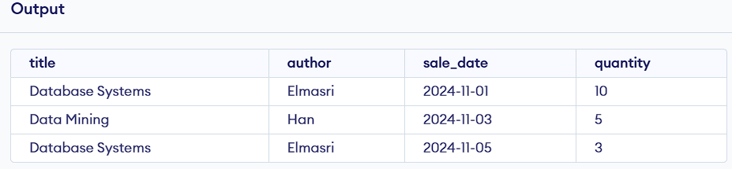

Experiment 12

Aim: Create two tables `Students` (student_id, name, age) and `Exams` (exam_id, student_id, subject, marks). Find the highest marks obtained in each subject.

Procedure:
1. Create the tables:

CREATE TABLE Students (
student_id INT PRIMARY KEY,
name VARCHAR(255),
age INT
);

CREATE TABLE Exams (
exam_id INT PRIMARY KEY,
student_id INT,
subject VARCHAR(255),
marks INT,
FOREIGN KEY (student_id) REFERENCES Students(student_id)
);

2. Insert values:

INSERT INTO Students (student_id, name, age) VALUES
(1, 'Alice', 20),
(2, 'Bob', 21),
(3, 'Charlie', 22);

INSERT INTO Exams (exam_id, student_id, subject, marks) VALUES
(1, 1, 'Math', 85),
(2, 2, 'Math', 90),
(3, 3, 'Science', 88),
(4, 1, 'Science', 92);

3. Query to find highest marks in each subject:

SELECT subject, MAX(marks) AS highest_marks
FROM Exams
GROUP BY subject;
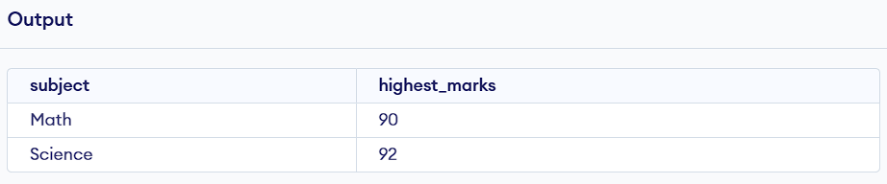

Experiment 13

Aim: Create two tables `Customers` (customer_id, name, city) and `Orders` (order_id, customer_id, order_date, amount). Calculate the total amount spent by each customer.

Procedure:
1. Create the tables:

CREATE TABLE Customers (
customer_id INT PRIMARY KEY,
name VARCHAR(255),
city VARCHAR(255)
);

CREATE TABLE Orders (
order_id INT PRIMARY KEY,
customer_id INT,
order_date DATE,
amount DECIMAL(10, 2),
FOREIGN KEY (customer_id) REFERENCES Customers(customer_id)
);

2. Insert values

INSERT INTO Customers (customer_id, name, city) VALUES
(1, 'John', 'New York'),
(2, 'Jane', 'Los Angeles'),
(3, 'Doe', 'Chicago');

INSERT INTO Orders (order_id, customer_id, order_date, amount) VALUES
(1, 1, '2024-11-01', 150.00),
(2, 2, '2024-11-02', 200.00),
(3, 1, '2024-11-03', 100.00);

3. Query to calculate total amount spent by each customer:

SELECT Customers.name, SUM(Orders.amount) AS total_spent
FROM Customers
JOIN Orders ON Customers.customer_id = Orders.customer_id
GROUP BY Customers.name;
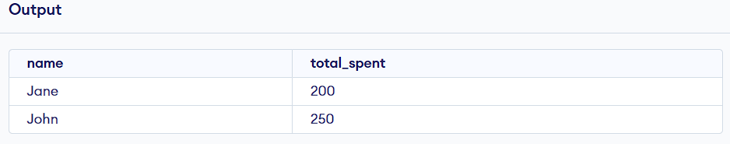

Experiment 14

Aim: Create two tables `Authors` (author_id, name, country) and `Books` (book_id, title, author_id). List the number of books written by each author.

Procedure:
1. Create the tables:

CREATE TABLE Authors (
author_id INT PRIMARY KEY,
name VARCHAR(255),
country VARCHAR(255)
);

CREATE TABLE Books (
book_id INT PRIMARY KEY,
title VARCHAR(255),
author_id INT,
FOREIGN KEY (author_id) REFERENCES Authors(author_id)
);

2. Insert values:

INSERT INTO Authors (author_id, name, country) VALUES
(1, 'J.K. Rowling', 'UK'),
(2, 'George R.R. Martin', 'USA'),
(3, 'J.R.R. Tolkien', 'UK');

INSERT INTO Books (book_id, title, author_id) VALUES
(1, 'Harry Potter', 1),
(2, 'A Game of Thrones', 2),
(3, 'The Hobbit', 3),
(4, 'Harry Potter and the Chamber of Secrets', 1);

3. Query to list the number of books written by each author:

SELECT Authors.name, COUNT(Books.book_id) AS book_count
FROM Authors
JOIN Books ON Authors.author_id = Books.author_id
GROUP BY Authors.name;
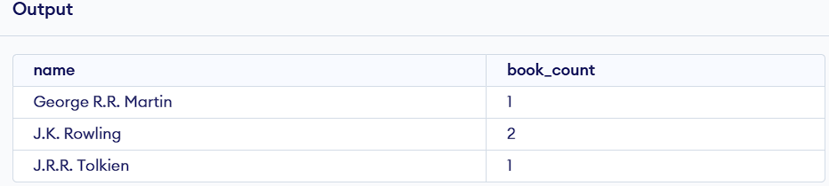

Experiment 15

Aim: Create two tables `Employees` (emp_id, name, salary, dept_id) and `Departments` (dept_id, dept_name). Find the average salary for each department.

Procedure:
1. Create the tables:

CREATE TABLE Employees (
emp_id INT PRIMARY KEY,
name VARCHAR(255),
salary DECIMAL(10, 2),
dept_id INT,
FOREIGN KEY (dept_id) REFERENCES Departments(dept_id)
);

CREATE TABLE Departments (
dept_id INT PRIMARY KEY,
dept_name VARCHAR(255)
);

2. Insert values:

INSERT INTO Departments (dept_id, dept_name) VALUES
(1, 'HR'), (2, 'IT'), (3, 'Finance');

INSERT INTO Employees (emp_id, name, salary, dept_id) VALUES
(1, 'Alice', 70000.00, 2), (2, 'Bob', 60000.00, 1), (3, 'Charlie', 80000.00, 3), (4, 'David', 75000.00, 2);

3. Query to find the average salary for each department:

SELECT Departments.dept_name, AVG(Employees.salary) AS avg_salary
FROM Employees
JOIN Departments ON Employees.dept_id = Departments.dept_id
GROUP BY Departments.dept_name;
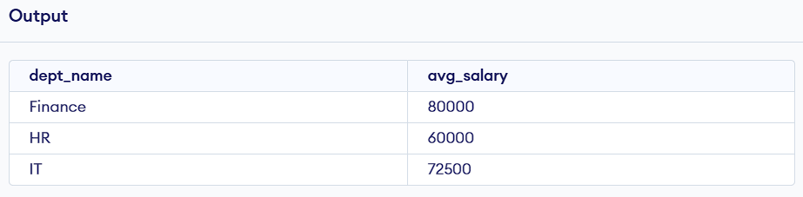

Experiment 16

Aim: Create two tables `Products` (product_id, name, price) and `Sales` (sale_id, product_id, quantity). Retrieve the total sales value for each product.

Procedure:
1. Create the tables:

CREATE TABLE Products (
product_id INT PRIMARY KEY,
name VARCHAR(255),
price DECIMAL(10, 2)
);

CREATE TABLE Sales (
sale_id INT PRIMARY KEY,
product_id INT,
quantity INT,
FOREIGN KEY (product_id) REFERENCES Products(product_id)
);

2. Insert values:

INSERT INTO Products (product_id, name, price) VALUES
(1, 'Pen', 1.50), (2, 'Notebook', 2.50), (3, 'Bag', 20.00), (4, 'Shoes', 50.00);

INSERT INTO Sales (sale_id, product_id, quantity) VALUES
(1, 1, 100), (2, 2, 200), (3, 3, 50), (4, 1, 150);

3. **Query to retrieve the total sales value for each product:**

SELECT Products.name, SUM(Sales.quantity * Products.price) AS total_sales
FROM Products
JOIN Sales ON Products.product_id = Sales.product_id
GROUP BY Products.name;
